MISSOURI GAMING COMMISSION
LEVEL II OCCUPATIONAL LICENSE APPLICATION

APPLICATION INSTRUCTIONS
THIS APPLICATION MUST BE SUBMITTED BY PERSONS SEEKING A LEVEL II OCCUPATIONAL LICENSE.

PLEASE READ ALL INSTRUCTIONS CAREFULLY BEFORE COMPLETING THIS APPLICATION.
- COMPLETING THIS APPLICATION:
  - You must make accurate statements and include all material facts. Any misrepresentation, or the failure to provide requested information, may result in the denial of your application and/or criminal charges being filed against you. Any statement that is not true or not disclosed which becomes known at any later date is cause for revocation of your occupational license. Notwithstanding the provisions under 610.110, RSMo, the Commission has access to both open and closed records as provided under 313.004, RSMo.
  - Prohibited acts, penalties--commission to refer violations to attorney general and prosecuting attorney-- venue for actions.
313.830.4. A person commits a class E felony and, in addition, shall be barred for life from excursion gambling boats under the jurisdiction of the commission, if the person:
(15) Knowingly makes a false statement of any material fact to the commission, its agents or employees.
  - Read each question carefully prior to answering. Answer every question completely. If a question does not apply to you, put N/A in only one box per page. If there is nothing to disclose in response to a particular question, indicate “None” in response to that question. Failure to provide a response to every question could result in the rejection of your application.
  - All entries on this application, except signatures, must be typed or printed legibly. If your application is not legible, it will not be accepted.
  - If the space available is insufficient to respond to a question, you are to supply the required information on an attachment page and clearly identify which question you are answering.
  - If you make any modification to the pre-printed questions or information contained in this application it will be rejected. Once your application is accepted, it becomes the property of the Missouri Gaming Commission and will not be returned.
IMPORTANT NOTICES

Persons submitting this application are required to be fingerprinted. You will be informed as to where you will be fingerprinted when you file this application.
You may be required to provide additional information or submit additional forms.

You must immediately notify the Missouri Gaming Commission of any changes in the information submitted in this application and related materials.
- BE SURE TO:
  - Sign the Verification form, the Public Disclosure Verification, and the Individual’s Request to Release Information in the presence of a notary public, justice of the peace, commissioner for declarations, or other person legally authorized to notarize your signature.
  - Bring valid driver license or other valid government issued photo ID.
  - Bring Missouri Gaming Commission badge if you have been issued one.
- BEFORE YOU SUBMIT THIS APPLICATION TO THE MISSOURI GAMING COMMISSION BE SURE:
  - You have reviewed the Missouri Gaming Commission’s filing instructions for the type of license that you are seeking.
  - You have included all required attachments listed in this application
  - The Individual’s Request to Release Information form is notarized on the original application.
  - Every question has been answered completely.
  - You retain a completed copy of your application packet for your own records.
- ATTACH A COPY OF:
  - Valid driver license or other valid government issued photo ID.
  - Department of Homeland Security documents authorizing legal presence in the United States if not a citizen.
  - Your naturalization certificate, if you are a naturalized citizen.

APPLICATION NO. | GAMING LICENSE NO. |  | SOCIAL SECURITY NO. |  | DATE OF BIRTH | AGE
CASINO
Company Name:
SUPPLIER
Company Name:
LICENSE TYPE
For this license type, applicant must be 21 or older ☐ L2 Level 2
An applicant 18 or over, but under 21 is eligible for a RESTRICTED license only ☐ R2 Level 2
NAME
LAST NAME |  |  |  |  |  | FIRST NAME |  |  |  |  | MIDDLE NAME
OTHER NAMES USED [E.G., MAIDEN NAME, ALL PREVIOUS MARRIED NAMES, ALIASES, AKA (ALSO KNOWN AS)]
ADDRESS
ENTER APPLICANT’S HOME ADDRESS, INCLUDING HOME AND MOBILE PHONE INFORMATION
STREET ADDRESS, SUITE NO., ETC.
PO BOX |  |  |  |  |  |  |  |  |  |  |  | HOME PHONE:
CITY: |  |  |  |  | STATE: |  |  |  | ZIP CODE: |  |  | MOBILE PHONE:
PLACE OF BIRTH: |  |  |  |  | COUNTRY OF CITIZENSHIP: |  |  |  |  |  |  | EMAIL ADDRESS:
ETHNIC ORIGIN
☐African |  | ☐African-American |  | ☐Alaska Native |  |  | ☐American Indian |  |  |  |  | ☐Asian |  | ☐Caucasian
☐ East Indian |  | ☐Hispanic |  | ☐Middle Eastern |  |  | ☐Pacific Islander |  |  |  |  | ☐Other
GENDER: | Male☐ | Female☐ | Other☐ |  |  |  | HEIGHT: ft. in. |  |  |  |  |  | WEIGHT: Pounds
HAIR
☐Auburn |  | ☐Bald |  | ☐Black |  |  |  | ☐Blonde |  | ☐Brown |  |  |  | ☐Gray
☐Red |  | ☐Salt/Pepper |  | ☐Sandy |  |  |  | ☐Strawberry |  | ☐White |  |  |  | ☐Other
EYES
☐Black |  | ☐Blue |  | ☐Brown |  |  |  | ☐Gray |  | ☐Green |  |  |  | ☐Hazel
☐Maroon |  | ☐Pink |  | ☐Other

WORK DEPARTMENT TO BE COMPLETED BY HUMAN RESOURCES
 | Accounting |  | Casino Host |  | Facilities |  | Hard Count |  | Management |  | Purchasing Department |  | Soft Count |  | Warehouse
 | Administration |  | Casino Operations |  | Finance |  | Hotel Sales |  | Marine Operations |  | Restaurant |  | Special Events
 | Admission |  | Club |  | Food & Beverage |  | Housekeeping |  | Marketing |  | Safety |  | Surveillance
 | Anti-Money Laundering |  | Consultant |  | General Management |  | Human Resources |  | MIS |  | Sales |  | Table Games
 | Audit |  | Count |  | Gift Shop |  | Information Technology |  | PBX |  | Security |  | Ticketing
 | Cage |  | EVS |  | Gold Card |  | Inventory Control |  | Players Club |  | Shuttle |  | Training Development
 | Casino Beverage |  | Executive |  | Guest Services |  | Maintenance |  | Property Operations |  | Slots |  | Wardrobe

JOB TITLE
OCCUPATIONAL CLASSIFICATION (TO BE COMPLETED BY THE CASINO HUMAN RESOURCES DEPARTMENT)
☐BLU Solid Blue (non-gaming) |  | ☐DIA Red Diagonal Stripes (gaming) |  | ☐GRE Solid Green (surveillance)
☐HOR Red Horizontal Stripes (non-gaming) |  | ☐RED Solid Red (security and guest safety) |  | ☐WHI Solid White (non-casino)
STATE OF MISSOURI
MISSOURI GAMING COMMISSION
APPLICANT ENTRY DATA

STATE OF MISSOURI
MISSOURI GAMING COMMISSION
APPLICANT ENTRY DATA

- DO YOU HOLD OR HAVE YOU EVER HELD A GAMING LICENSE IN ANY JURISDICTION?
If “YES” list jurisdiction(s) and note if active or inactive
YES NO
- IN THE LAST 30 DAYS, HAVE YOU APPLIED FOR A LICENSE AT ANOTHER CASINO IN MISSOURI?
If “YES” list casino(s)
YES NO
- HAS YOUR LICENSE EVER BEEN DENIED OR REVOKED IN ANY OTHER JURISDICTION?
If “YES” list jurisdiction(s)
YES NO
- ARE YOU ON THE DISASSOCIATED PERSON (DAP) VOLUNTARY EXCLUSION LIST?
YES NO
- WHAT IS YOUR PRIMARY LANGUAGE?
- DO YOU HAVE ANY VISIBLE SCARS, TATTOOS, OR OTHER DISTINGUISHING MARKS AND/OR CHARACTERISTICS? IF SO, DESCRIBE.

CIVIL, CRIMINAL, AND INVESTIGATORY PROCEEDINGS
The next question asks about any arrests, charges, or offenses you have committed. Prior to answering this question, carefully review the definitions and instructions which follow.
DEFINITIONS: For purposes of this question:
    - “Arrest” includes any detaining, holding, or taking into custody by any police or other law enforcement authorities to
answer for the alleged performance of any “offense”.
    - “Charge” means any indictment, complaint, information, summons, ticket, or other notice of the alleged commission of any “offense”.
    - “Offense” means all felonies, crimes, misdemeanors, municipal ordinance violations, military court-martials, and violations of probation or other court order. An “offense” does not include traffic or parking violations, except for driving while revoked/suspended, alcohol/drug-related traffic violations, and leaving the scene of an accident.
INSTRUCTIONS: 1. Answer “YES” and provide all information to the best of your ability EVEN IF:
- You did not commit the offense charged;
- The charges were dismissed or subsequently downgraded to a lesser charge;
- You completed a Pretrial Intervention (PTI) or equivalent diversionary program in other jurisdictions;
- You were not convicted;
- You did not serve any time in prison or jail;
- The charges or offenses happened a long time ago (This does not include cases heard in Juvenile Court in their entirety);
- If any records relating to a charge, an arrest, or conviction have been expunged or otherwise officially sealed by a court or government agency;
- You have a SIS (Suspended Imposition of Sentence).
- Pursuant to 313.004, RSMo, Missouri Gaming Commission has access to both open and closed records. When in doubt about disclosure of closed record, seek legal counsel.
IMPORTANT
Missouri Gaming Commission investigators will make inquiries to establish whether the applicant has had any involvement with law enforcement agencies.
Failure to disclose any such involvement will be taken into account in assessing your character, honesty, and integrity, and may result in denial of your application and/or criminal charges being filed against you.
Have you ever been arrested or given a ticket for driving while intoxicated or under the influence of alcohol or drugs; driving while license is under suspension or revocation; or leaving the scene of an accident? If yes, complete the following chart:
Yes No
Have you ever been arrested, detained, charged, indicted, convicted, pleaded guilty or nolo contendere (no contest), or forfeited bail concerning any crime or offense, in any federal, state, or local jurisdiction, including any findings or pleas in a suspended imposition of sentence?
If yes, complete the following chart: Yes No
NATURE OF CHARGE OR OFFENSE/ LOCATION OF WHERE INCIDENT OCCURRED | DATE OF CHARGE OR OFFENSE | NAME AND ADDRESS  OF LAW ENFORCEMENT AGENCY OR COURT INVOLVED | DISPOSITION  (ENTERED GUILTY PLEA, RECEIVED SIS, PROBATION, DISMISSED, PENDING, ETC.) | SENTENCE

Missouri Gaming Commission
NOTICE OF DUTY TO DISCLOSE
ARRESTS AND CONVICTIONS
The Missouri Gaming Commission (Commission) has advised the following person (Applicant) of their
duty to disclose all arrests and convictions when applying for an occupational gaming license:
Name: ________________________________________ SSN: _____________________________________

Pursuant to 11 CSR 45-4.260(4)(D), the Commission may deny an occupational gaming license to any Applicant who fails to disclose any arrest or conviction on their application for an occupational gaming license. This duty to disclose includes all arrests, which shall include any incidents in which the Applicant was detained, held, or taken into custody by law enforcement officials for questioning about an alleged criminal offense, regardless of whether or not the charges for which the Applicant was arrested were later dropped, dismissed, or nolle prosequi. This duty to disclose also includes all convictions, including military court-martial convictions and any conviction in which the Applicant has been found guilty of, plead guilty to, plead nolo contendre to, or entered an Alford plea to a crime, as well as any conviction in which the Applicant received a Suspended Imposition of Sentence (SIS), regardless of whether or not the record of conviction is currently a closed or expunged record.
Failure by the Applicant to disclose any arrest or conviction may result in the DENIAL of the Applicant’s application for an occupational gaming license and/or the termination of any temporary gaming license that may have been issued.

The following examples are intended to help the Applicant better understand their duty to disclose but are not designed to include every situation in which an Applicant has a duty to disclose an arrest or conviction.
ANY APPLICANT WHO HAS QUESTIONS ABOUT OR DOES NOT FULLY UNDERSTAND THEIR DUTY TO DISLCOSE ALL ARRESTS AND CONVICTIONS SHOULD NOT COMPLETE THE APPLICATION PROCESS UNTIL SUCH TIME AS THE APPLICANT FULLY UNDERSTANDS THIS DUTY TO DISLCOSE

Example #1: Applicant pleads guilty to a crime and receives an SIS and 2-years’ probation. Applicant successfully completes the 2-years’ probation, and Applicant’s court records are closed. Applicant must disclose this conviction to the Commission despite any advice the Applicant may have received from an attorney or judge to the contrary.

Example #2: Applicant is arrested for a crime, but the charges are later dropped, dismissed, or nolle prosequi by the prosecutor. Applicant must disclose this arrest to the Commission despite any advice the Applicant may have received from an attorney or judge to the contrary.

Example #3: Applicant is arrested for, or convicted of a crime in another state or jurisdiction. The Applicant must disclose this arrest or conviction to the Commission despite any advice the Applicant may have received from an attorney or judge to the contrary.

Example #4: Applicant is handcuffed by police, taken to the police station, fingerprinted, and held for questioning, but later released without any charges being filed against them. Applicant must report this interaction to the Commission despite any advice the Applicant may have received from an attorney or judge to the contrary.

Example #5: Applicant is charged, pleads guilty to, or is found guilty of any offense and is granted an expungement. Applicant must disclose any expunged offenses as required per section 610.140.9, RSMo.

Example #6: Applicant is arrested and convicted of a crime and sentenced to 2-years in prison. Applicant later receives a full pardon from the Governor. Applicant must disclose this arrest and conviction to the Commission despite any advice the Applicant may have received from an attorney or judge to the contrary.

Acknowledgement of Understanding of Duty to Disclose: Applicant freely acknowledges that they have read this form and fully understand their duty to disclose all arrests and convictions to the Commission.

Signature of Applicant: _________________________________ Date: ____________________________
Acknowledgement of Receipt: The undersigned hereby certifies that the Applicant was provided adequate time in which to read and examine this form, that Applicant indicated to the undersigned that they fully understood their duty to disclose all arrests and convictions to the Commission, and that the Applicant signed the foregoing in exercise of their own free will on this, the_____ day of_______________, 20____.

___________________________________________________________________________________________________________
MGC Signature Printed Name Title/Position
VERIFICATION
I, , state as follows:

      - I am the applicant who is submitting this application.

      - I personally supplied the information contained in this application.

      - I read and understand the English language or I have had an interpreter read, explain, and record the answer to each and every question on this application.

      - Any document accompanying this application, which is not an original document, is a true copy of the original document.

      - I certify that the foregoing statements made by me are true, complete, and accurate to the best of my knowledge. I am aware that if any of the foregoing statements made by me are knowingly false, I am subject to criminal charges.

(Applicant’s Signature)

PUBLIC DISCLOSURE VERIFICATION
I, , state as follows:

  - I am the applicant submitting this Public Disclosure Section;
  - I personally supplied the information contained in this application;
  - I understand and agree that the Public Disclosure Form will be provided to any member of the public who requests this information from the Missouri Gaming Commission. I further understand my continuing obligations to update and supplement this application if any of the information provided changes;
  - I certify that I have read and agree to abide by the terms of the Riverboat Gaming Act and any rule promulgated by the Commission; and
  - I certify that the information contained in this application is true, complete, and accurate to the best of my knowledge and belief.

(Applicant’s Signature)

INDIVIDUAL’S REQUEST TO RELEASE INFORMATION

To:

From:
(Applicant’s Name)
  - I hereby authorize and request all persons or entities to whom this request is presented having information relating to or concerning me to furnish such information to a duly appointed agent of the Missouri Gaming Commission or Missouri Highway Patrol, whether or not such information would otherwise be protected from disclosure by any constitutional, statutory or other legal privilege.
  - I hereby authorize and request all persons or entities to whom this request is presented having documents relating to or concerning me to permit a duly appointed agent of the Missouri Gaming Commission or Missouri Highway Patrol, to review and copy any such documents, whether or not such documents would otherwise be protected from disclosure by any constitutional, statutory or other legal privilege.
  - If the person or entity to whom this request is presented is a brokerage firm, bank, savings and loan, or other financial institution or an officer of same, I hereby authorize and request that a duly appointed agent of the Missouri Gaming Commission or Missouri Highway Patrol, shall be permitted to review and obtain copies of any and all documents, records or correspondence pertaining to me, including, but not limited to, past loan information, notes cosigned by me, checking account records, savings deposit records, safe deposit box records, passbook records and general ledger folio sheets.
  - I hereby authorize disclosure of all financial records pertaining to my relationship with any financial institution pursuant to the Missouri Right to Financial Privacy Act, sections 408.675 to 408.700, RSMo, for twenty-four (24) months from the date of execution or at the termination of all licenses issued to me by the Missouri Gaming Commission, whichever occurs later. I understand that I may revoke this authorization at any time before the financial records are disclosed. I authorize disclosure of the financial records identified above to the Missouri Highway Patrol and /or Missouri Gaming Commission for the purpose of evaluating my application for a gaming license, and acknowledge that said agencies have complied with and afforded all applicable rights under Sections 408.675 to 408.700, RSMo
  - I do hereby make, constitute and appoint any duly appointed agent of the Missouri Gaming Commission or Missouri Highway Patrol, my true and lawful attorney-in-fact, for me in my name, place, stead, and on my behalf and for my use and benefit:
    - To request, review, copy, sign for, or otherwise act for investigative purposes with respect to documents and information in the possession of the person or entity to whom this request is presented as I might;
    - To name the person or entity to whom this request is presented and insert that person’s or entity’s name in the appropriate location on this request; and
    - To place the name of the Missouri Gaming Commission or Missouri Highway Patrol agent, presenting this request in the appropriate location on this request.
  - I grant to said attorney-in-fact full power and authority to do, take, and perform all and every act and thing whatsoever requisite, proper, or necessary to be done, in the exercise of any of the rights and powers herein granted, as fully to all intents and purposes as I might or could do if personally present, with full power of substitution or revocation, hereby ratifying and confirming all that said attorney-in-fact, or his/her substitute(s) shall lawfully do or cause to be done by virtue of this power of attorney and the rights and powers herein granted.
  - This power of attorney ends twenty-four (24) months from the date of execution or at the termination of all licenses issued to the applicant/me by the Missouri Gaming Commission, whichever occurs later.
  - I do, for myself, my heirs, executors, administrators, successors and assigns, hereby release remise, and forever discharge the person or entity to whom this request is presented, and his/her/its agents and employees from any and all manner of actions, causes of action, suits, debts, judgments, executions, claims, and demands whatsoever, known or unknown, in law or equity, which I ever had, now have, may have, or claim to have against the person or entity to whom this request is presented or his/her/its agents or employees arising out of or by reason of complying with this request.
  - I agree to indemnify and hold harmless the person or entity to whom this request is presented and his/her/its agents and employees from and against all claims, damages, losses and expenses, including reasonable attorneys’ fees arising out of or by reason of complying with this request.
  - A reproduction of this request by photocopy shall be for all intents and purposes as valid as the original.
IN WITNESS WHEREOF, I have executed this request at ,
(City) (State)
on the day of , 20

(Applicant’s Signature)
Subscribed and sworn to before me this day of , 20

(Notary Public)
(Notarial Seal)

My commission expires:
Notary Public in and for the County of

State of

Missouri Applicant Fingerprint Privacy Notice
The Missouri Applicant Fingerprint Privacy Notice includes three (3) parts:
- The State and National Rap Back Privacy Notice
- The Noncriminal Justice Applicant Privacy Rights
- The Privacy Act Statement

State and Federal Rap Back Privacy Notice
Applicants submitting their fingerprint images to the Central Repository for a fingerprint based criminal record check are advised that their fingerprint images will be retained in state and federal biometrics databases, pursuant to Section 43.540 RS Mo. If the submitting agency participates in the State or State and National Rap Back Programs, fingerprint images will be submitted, searched, and retained for the purpose of being searched against future submissions to the State and National Rap Back Programs. Fingerprint searches will also include latent print searches.

The "Missouri Rap Back Program" and "National Rap Back Program" shall include any type of

automatic notification made by the State of Missouri and/or the Federal Bureau of Investigation through the Missouri State Highway Patrol to a qualified entity indicating that an applicant who is employed, licensed, or otherwise under the purview of the qualified entity has been arrested for a reported criminal offense and the fingerprints for that arrest were forwarded to the Central Repository or the Federal Bureau of Investigation by the arresting agency.

By signing the Missouri Applicant Fingerprint Privacy Notice you are acknowledging the receipt of and agreeing to the terms of the State and National Rap Back Privacy Notice, the Noncriminal Justice Applicant Privacy Rights, and the Privacy Act Statement.
NAME (Please Print):
SIGNATURE: DATE:

Spanish version to follow –

Aviso de privacidad de la huella digital del solicitante de Missouri

El Aviso de privacidad de la huella digital del solicitante de Missouri incluye tres (3) secciones.
- El Estado y el Aviso de Privacidad Nacional de Rap Back
- Los derechos de privacidad del solicitante de justicia no penal
- La Declaración de la Ley de Privacidad

Aviso de privacidad estatal y federal de Rap Back
Se recomienda a los solicitantes que envíen sus imágenes de huellas dactilares al Repositorio Central para una verificación de antecedentes penales basada en huellas dactilares que sus imágenes de huellas dactilares se conservarán en las bases de datos biométricos estatales y federales, de conformidad con la Sección 43.540 RSMo. Si la agencia remitente participa en los Programas estatales o estatales y nacionales de devolución de respaldo, las imágenes de huellas dactilares se enviarán, buscarán y conservarán con el fin de realizar búsquedas en futuras presentaciones a los programas estatales y nacionales de Respuesta de retorno; Las búsquedas de huellas digitales también incluirán búsquedas de impresiones latentes.

El "Programa de Devolución Rápida de Missouri" y el "Programa Nacional de Respuesta
Rápida" incluirán cualquier tipo de notificación automática realizada por el Estado de Missouri y
/ o la Oficina Federal de Investigaciones a través de la Patrulla de Carreteras del Estado de Missouri a una entidad calificada que indique que un solicitante que es empleado, licenciado o de otro modo bajo el ámbito de la entidad calificada ha sido arrestado por una ofensa criminal denunciada y las huellas dactilares para ese arresto fueron enviadas al Depósito Central o al Buró Federal de Investigaciones por la agencia de arresto.

Al firmar el Aviso de Privacidad de Huellas Digitales del Solicitante de Missouri, usted está aceptando que recibió y está de acuerdo con los términos del Aviso de Privacidad de Rap Back del Estado y Nacional, los Derechos de Privacidad del Solicitante de Justicia No Penal y la Declaración de la Ley de Privacidad.

Firma: ________________________________________________ Fecha: _____________

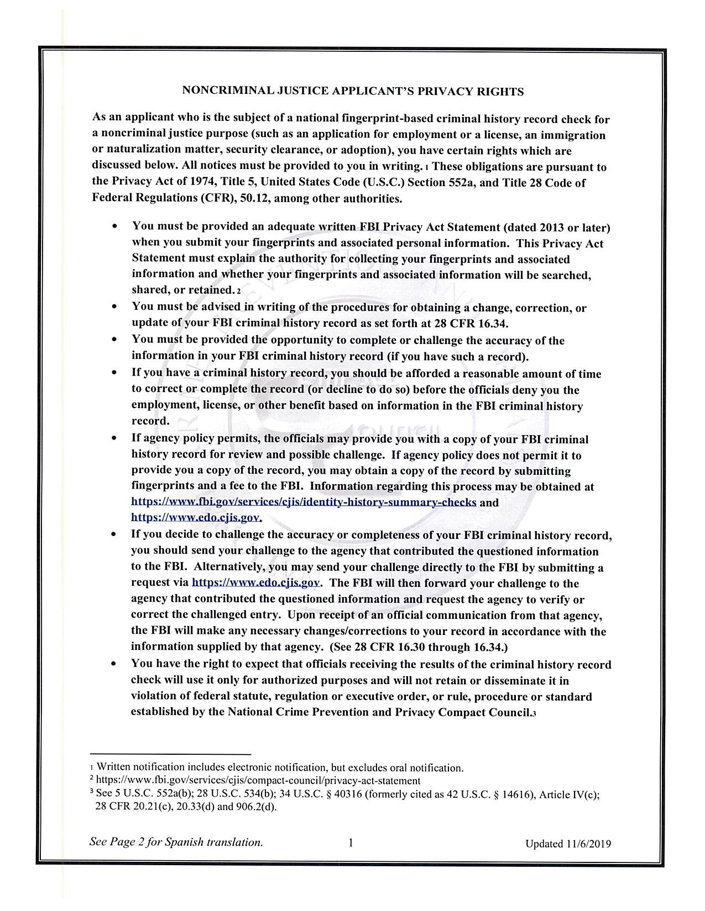

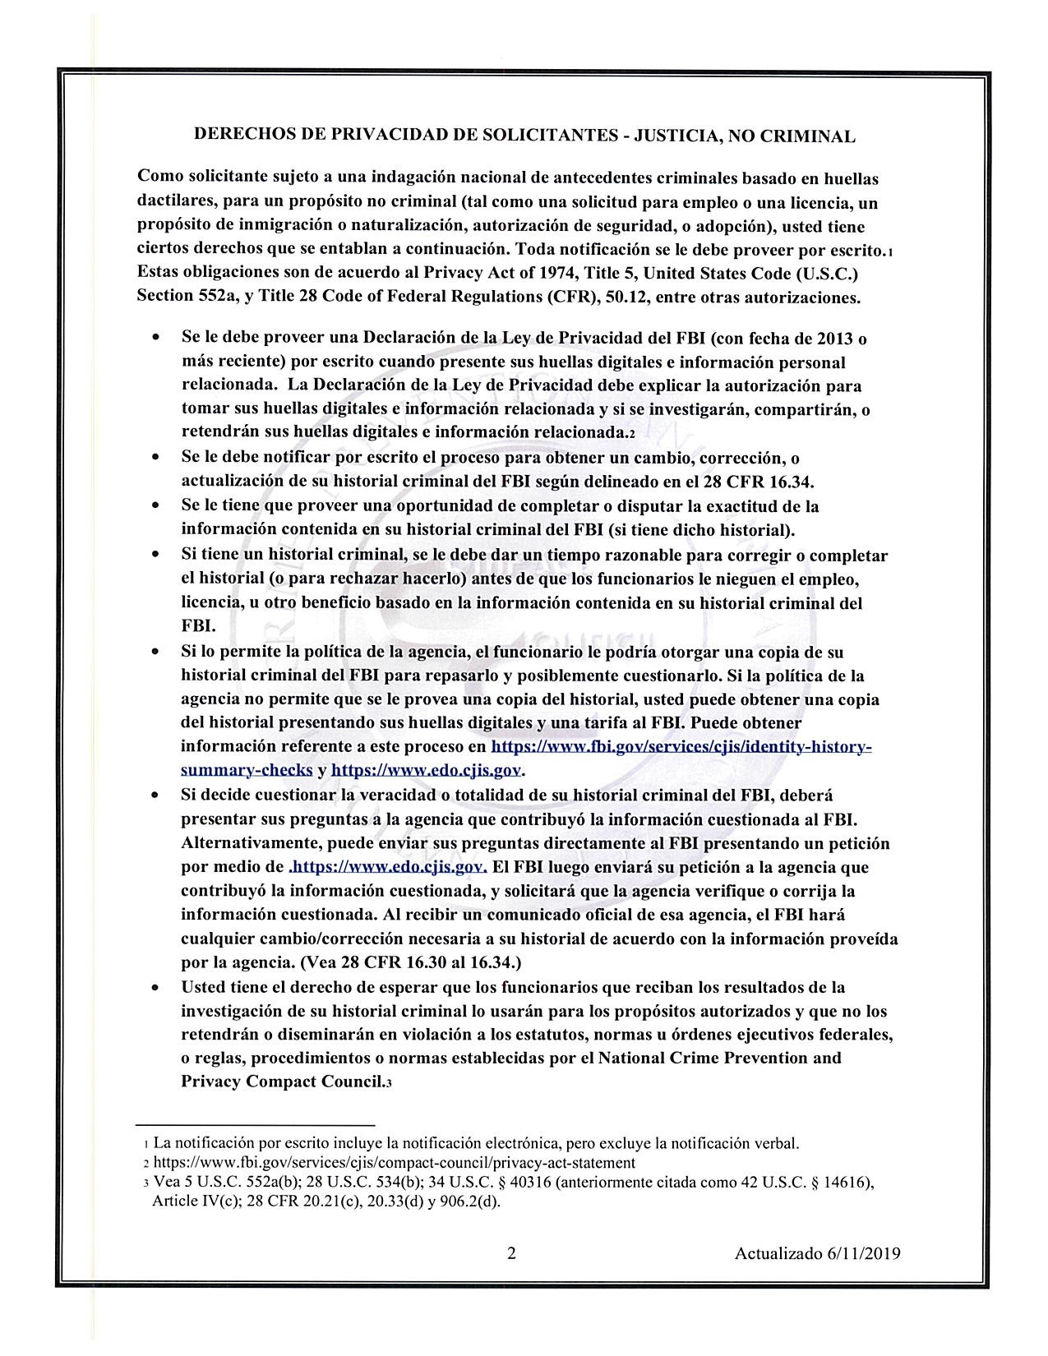

Privacy Act Statement
This privacy act statement is located on the back of the FD-258fingerp.dnL.c.ard.

Authority: The FBI's acquisition, preservation, and exchange of fingerprints and associated information is generally authorized under 28 U.S.C. 534. Depending on the nature of your application, supplemental authorities include Federal statutes, State statutes pursuant to Pub. L. 92-544, Presidential Executive Orders, and federal regulations. Providing your fingerprints and associated information is voluntary; however, failure to do so may affect completion or approval of your application.

Principal Purpose: Certain determinations, such as employment, licensing, and security clearances, may be predicated on fingerprint-based background checks. Your fingerprints and associated information/biometrics may be provided to the employing, investigating, or otherwise responsible agency, and/or the FBI for the purpose of comparing your fingerprints to other fingerprints in the FBI's Next Generation Identification (NGI) system or its successor systems (including civil, criminal, and latent fingerprint repositories) or other available records of the employing, investigating, or otherwise responsible agency. The FBI may retain your fingerprints and associated information/biometrics in NGI after the completion of this application and, while retained, your fingerprints may continue to be compared against other fingerprints submitted to or retained by NGI.

Routine Uses: During the processing of this application and for as long thereafter as your fingerprints and associated information/biometrics are retained in NGI, your information may be disclosed pursuant to your consent, and may be disclosed without your consent as permitted by the Privacy Act of 1974 and all applicable Routine Uses as may be published at any time in the Federal Register, including the Routine Uses for the NGI system and the FBI's Blanket Routine Uses. Routine uses include, but are not limited to, disclosures to: employing governmental or authorized non-governmental agencies responsible for employment, contracting, licensing, security clearances, and other suitability determinations; local, state, tribal, or federal law enforcement agencies; criminal justice agencies; and agencies responsible for national security or public safety.

As of 03/30/2018

See Page 2 for Spanish translation

